**Linux System Administration**

Why linux:

1. Open Source
2. Free to run the program for any purpose
3. Free to study how the prgram works
4. Free to change how the program worlds
5. Free to redistribute copies

Linux Distribution:

1. Collection of software
2. Package management system
3. Helps you install, upgrade and remove software
4. Keep server up to date and secure

Popular Distribution:

1. Red Hat
   1. CentOS
   2. Fedora
2. Debian
   1. Ubuntu
   2. Mint
3. SuSE
4. Gentoo
5. Arch
6. Slackware

How can we run LINUX?

1. Your own PC
2. Someone else’s PC
   1. Shared Hosting
   2. Cloud Provider
      1. Amazon Web Services
      2. Google Cloud
      3. Microsooft Azure
3. Virtualization
   1. VirtualBox
   2. VMWare

Linux Basic Commands:

1. Show username:

$ uname -a

1. Show Current date

$ date

Switching to Bridged Networking:

1. Connecting via SSH connection.

**Determine and Configure Hardware Settings:**

1. Udev
   1. Device manager
   2. Low lwvel access to the linux device tree
   3. Handles user space events
      1. Ex. Loading Firmware
   4. Provided by temporary filesystem (tmpfs)
   5. Mounted to /dev on startup
2. Dbus
   1. Inter-process communication mechanism
   2. Framework that allows processes to talk each other
   3. Secure
   4. Reliable
   5. Provides high-level object oriented programming interface

**Command:**

1. **Process check:**

**$ ps aux | head**

1. **Message check:**

**$ sudo dmesg**

**$ sudo dmesg -T**

1. **Hardware devices:**

**$ cd /dev**

**$ls ( We can see all the hardware devices here)**

# sysfs

* Virtual filesystem
* Presents information about various kernel subsystems
  + Hardware devices
  + Drivers
* **Mounted to /sys**

# procfs

* Similar to sysfs
* Presents information about process
* Presents information about system information
* **Mounted to /proc**
  + Can be used to interface with the kernel
  + Change parameters on the fly

**$ cd /proc**

**$ cat cmdline(kernel version)**

**$ cat version(linux version)**

**$ cat cpuinfo( CPU information)**

**$ lsmod( check the module are running on the system)**

**$ lsmod | less ( page by page used module shows)**

**$ sudo rmmod [module name] ( used to remove the module)**

**$ sudo modprobe [module name] ( restart the module)**

**$ lspci ( See how hardware are configured/ all the pci devices connected to the system)**

**$ lspci -v**

**$ lspci -vvv ( show all the devices connected to the system)**

**# Run levels, boot targets also Shutdown and reboot a system:**

**@ Run levels:**

* **0 -( Halt or shut down the system)**
* **1 -( single user mode)**
* **2 -(Multi user mode without networking)**
* **3 -(Normal boot)**
* **4 -(Unused/ Customizable)**
* **5 -(Run level 3 + GUI display manager)**
* **6 - ( Reboot)**

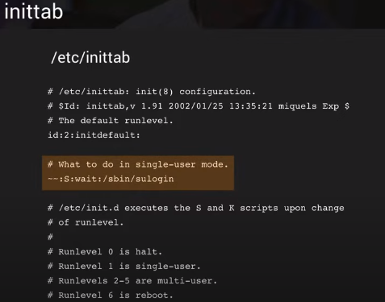

**$ man telinti ( showing the various service such as reboot, shutdown and many more)**

**$ sudo wall Rebooting? ( Shows notification all the windows that system will rebooting)**

**$ systemctl (Shows all the running service)**

**$ sudo systemctl status [service name]**

**$ sudo systemctl stop [service name]**

**$ sudo systemctl strat [service name]**

**$ sudo systemctl restart [service name]**

**$ sudo systemctl enable [service name]**

**$ sudo systemctl enable multi-user.target**

**$ sudo systemctl set-default multi-user.target**

**# Designing Hardisk Layout:**